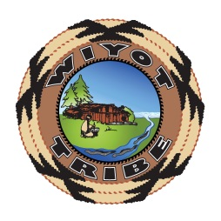
For Immediate Release
01/21/2026

BREAKING GROUND ON LAQILH HOU DAQH (WHERE THE ELDERS ARE)

Eureka— 01/21/2026 The Wiyot Tribe, Dishgamu Humboldt Community Land Trust, Travois, Pacific Builders and Raymond James gathered on January 21st to break ground on the construction phase of the Laqilh Hou Daqh (Where the Elders Are) Housing Development in Eureka at 6th and L streets. The new affordable elders housing development will provide 52 senior apartment units. This site was awarded to the Tribe through the City of Eureka Parking Lots to Affordable Housing RFP and is expected to be completed in 2027.
Laqilh Hou Daqh will provide 24 studio bedroom, 20 one bedroom and 8 two-bedroom units. Community amenities include a community room, commercial kitchen, elders programming space, and above ground green space.
California and our local community have a large and growing elders’ population with increasing housing needs. This affordable housing development addresses the high cost of living strains on fixed incomes, giving elders affordable options essential for elders. When elders dedicate most of their income to housing, they often have to cut back on essential food and medical care, causing their health to suffer. Affordable housing provides better access to medical services, nutrition, and transportation, supporting healthier lifestyles. Laqilh Hou Daqh offers built-in social networks and wellness activities, combating isolation. Affordable housing provides stability, protecting against eviction and homelessness, which disproportionately affect older adults.

Living our Values
Dishgamu Humboldt believes in our interconnectedness and pursues projects that will benefit all people in our community as well as the environment. Laqilh Hou Daqh is being developed on a parking lot, formerly owned by the City of Eureka, fulfilling Dishgamu’s values by developing infill housing on vacant or underused land within existing urban areas, integrating sustainability by reducing sprawl, cutting transportation emissions through walkability, using existing infrastructure efficiently, and incorporating green technologies, offering a key strategy for climate-friendly density and revitalizing communities. By using local contractors, the project provides local living wage jobs. This project leverages existing services, reduces habitat conversion, and increases affordable housing units with significantly lower overall carbon footprint compared to building in undeveloped areas. This development aligns with "smart growth" principles by focusing on compact, mixed-use development near transit.

##

Quotes from the Groundbreaking
“ Unlike the Joni Mitchell song, “they paved paradise and put in a parking lot,” Dishgamu intends to create a paradise providing affordable homes for elders, programing services for elders, and adding above ground native plant green space where there was a paved parking lot.”
~Michelle Vassel, Tribal Administrator, Dishgamu Director

“A great day for Eureka! Working government to government for a better Eureka. I appreciate our relationship and partnership with the Wiyot Tribe and look forward years of building relationships, healing and projects.”
~Kim Bergel, Mayor of Eureka

“I am grateful the Wiyot Tribe is working for elders housing. Elders are the Tribe’s first priority, to make sure they have a safe place to live. I am also grateful to work with the City of Eureka and to provide jobs for the community.”
~Brian Mead, Chair Wiyot Tribe

“I am very grateful there will be housing for elders. This will give the Tribe opportunities to help elders get affordable housing.”
~Hazel James, Vice Chair Wiyot Tribe

“So very thankful to see where this begins and proud of where this goes.”
~Melinda Ramirez, Councilmember

“Travois & Travois Architecture are excited to kick off construction on the Laqilh Hou Daqh Project. We are proud to bring our experience in partnering with Tribes for Low Income Housing Tax Credit projects to the Wiyot Tribe and Eureka.”
~Laura Herron ~ Travois

“Raymond James affordable housing investments is proud to work with the Wiyot Tribe to bring the Laqilh Hou Daqh project to life! We look forward to continue to work with the Wiyot Tribe in bringing safe and affordable housing to the people of Eureka.“
Kara Coughlin~ Raymon James

“Pacific Builders wants to thank you for the opportunity to be part of this amazing project and we look forward to seeing the positive impact on the lives of elders.”
~Kodie Boyer, Project Manager, Pacific Builders

“Thank you for recognizing the need and importance of affordable housing; as a Wiyot Tribal member I’m excited and proud to see the Tribe and City partnering to bring these opportunities for community investment. I feel honored to be a part of the project and the continued success of the Wiyot people.”
~Mandy Mager, Pacific Builders

Our Partners
Dishgamu Humboldt Community Land Trust is the first-ever tribally-owned community land trust, established by the Wiyot Tribe to facilitate the return of ancestral lands to Wiyot stewardship. The word "Dishgamu" means "love" in the Soulatluk language. The primary goal of the Dishgamu Humboldt Community Land Trust is to restore the balance between people and the land by prioritizing the Wiyot community. Its work is rooted in cultural and environmental restoration, as well as providing affordable housing and workforce development opportunities in Wiyot ancestral territory.

Travois is a mission-driven consulting firm that specializes in promoting housing and economic development for American Indian, Alaska Native, and Native Hawaiian communities. Travois supports Indigenous clients in building affordable housing and growing their economies, with a goal of ensuring every family has a safe home and every person has a good job. The company offers a range of services, including housing and economic development consulting, architectural design and construction monitoring, asset management, and compliance services. They are experts in using funding sources like the Low Income Housing Tax Credit (LIHTC) and New Markets Tax Credit (NMTC) programs to secure private investor equity for projects in Indian Country.

Raymond James Affordable Housing Investments (RJAHI), has a history of partnering with Native American tribes on housing initiatives. The firm has partnered with 38 tribes, invested over $300 million in tribal Low-Income Housing Tax Credit (LIHTC) transactions and has financed the development or renovation of more than 2,800 homes.

Pacific Builders is local family owned general contracting company based in Arcata, CA, which serves Humboldt County and surrounding areas. This location specializes in custom residential and commercial construction, including design-build services and handling project planning/permitting processes.

City of Eureka is converting several public parking lots into affordable housing developments, fulfilling state mandates with projects led by developers like the Wiyot Tribe’s Dishgamu Humboldt Community Land Trust’s Laqilh Hou Daqh at 6th & L. Eureka is required to plan for nearly 1000 new housing units, with a significant portion needing to be affordable, they are creating opportunities within city boundaries by repurposing city-owned land like parking lots.

Photos from the Ground Breaking

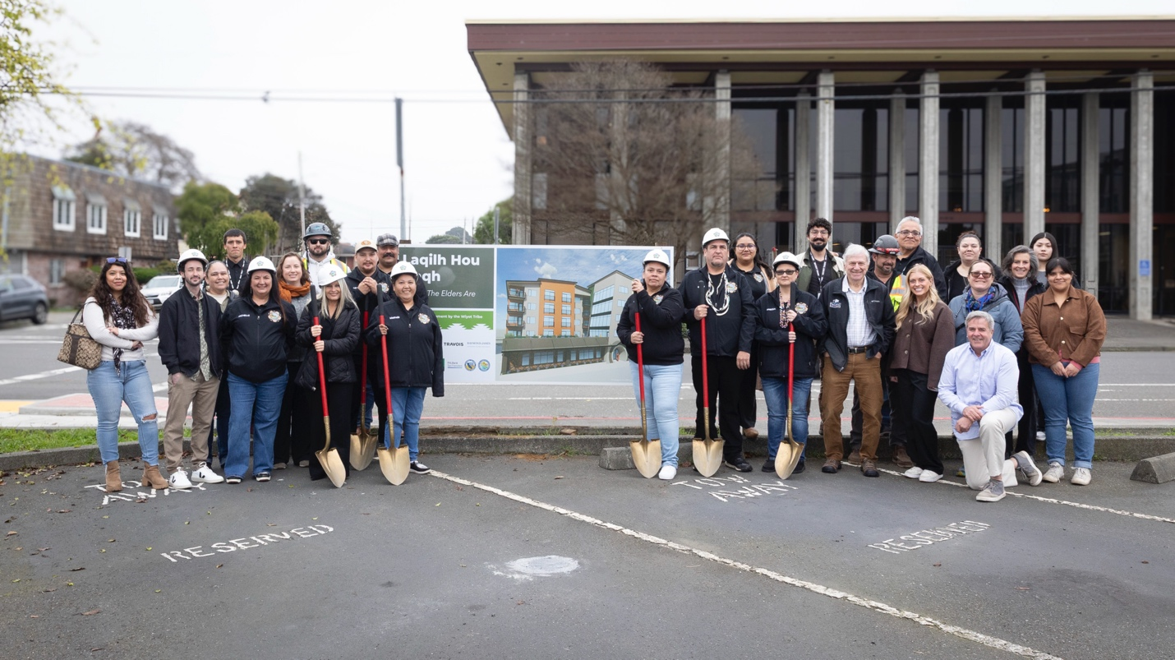
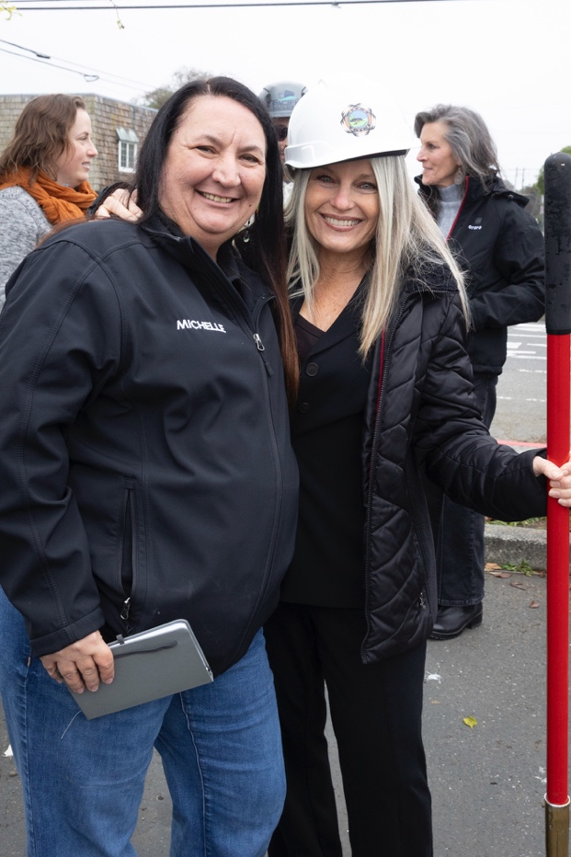
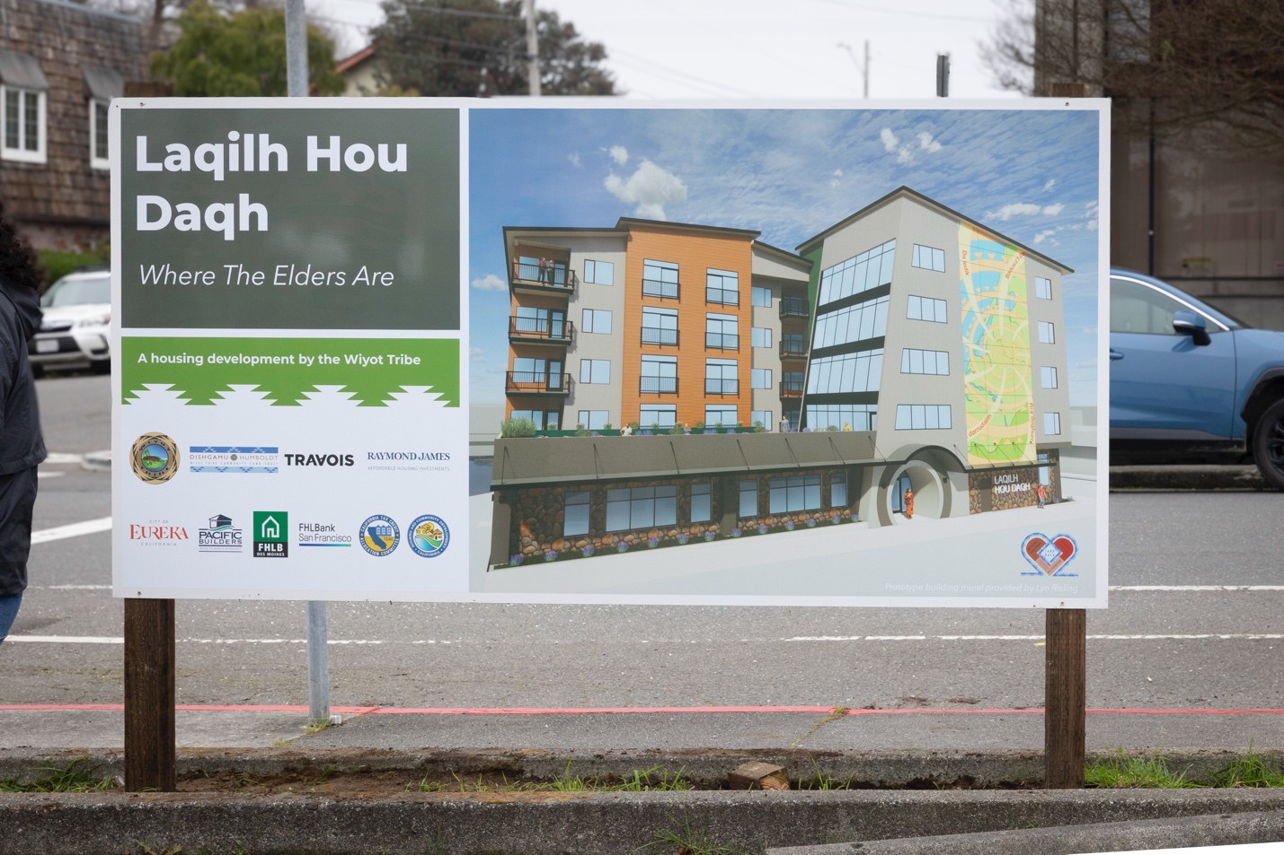
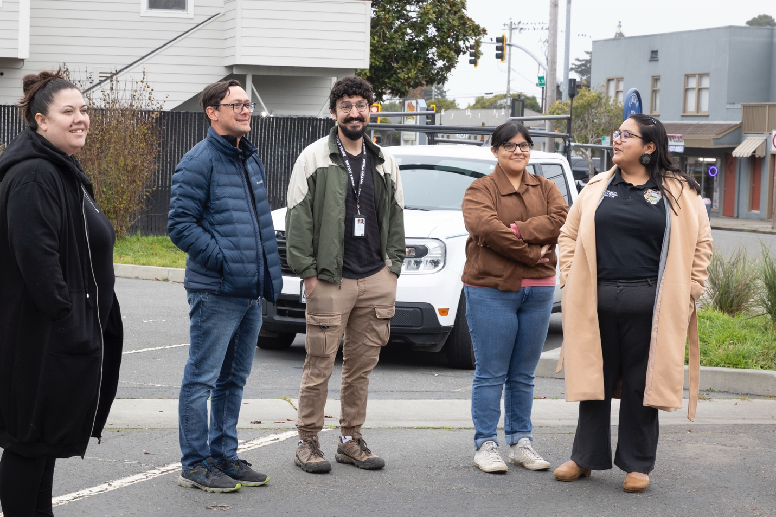
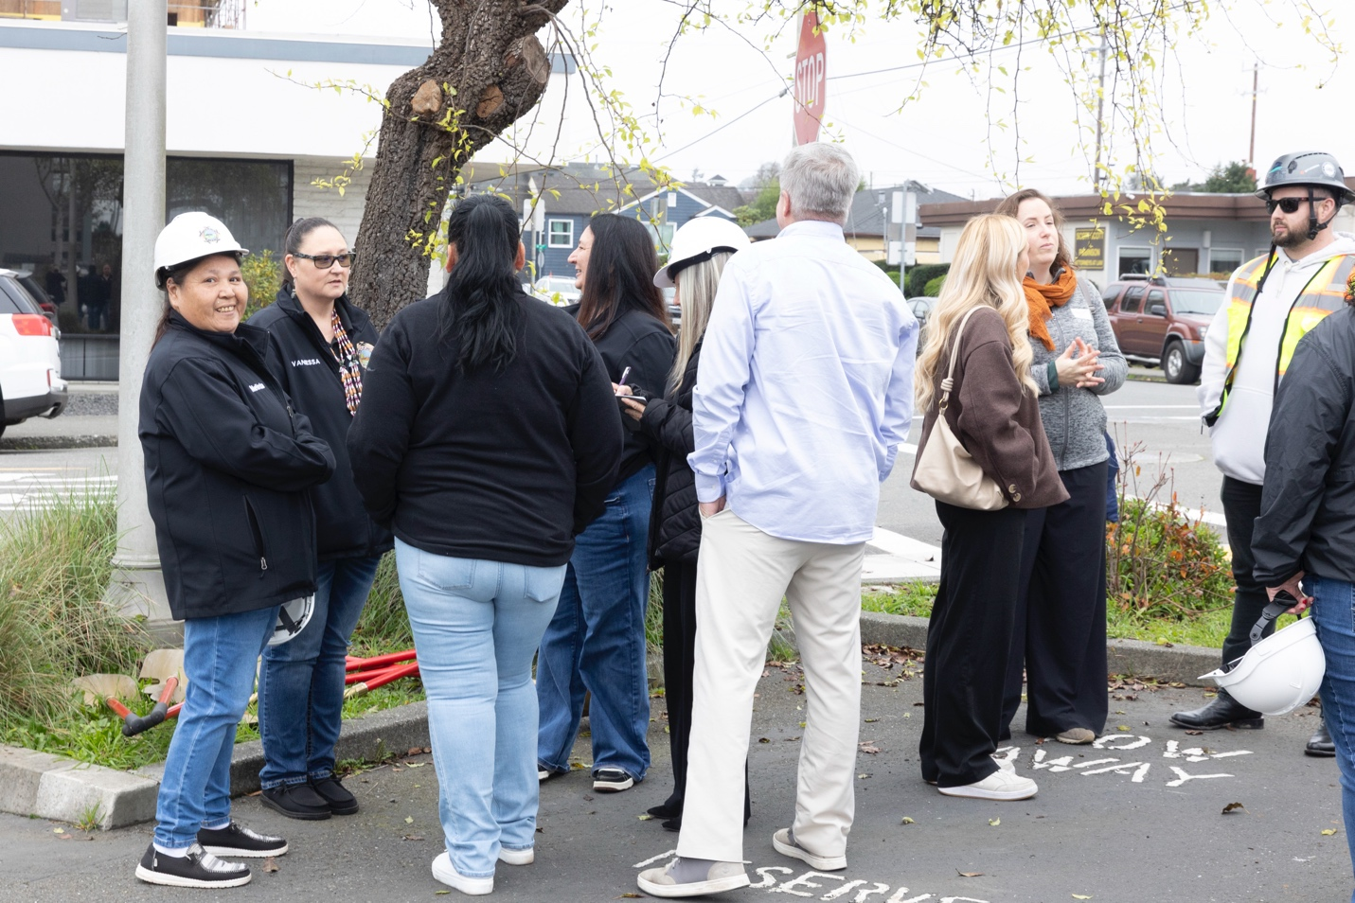

Laqilh Hou Daqh Vinettes
